# Nithin Das, 10422784, Date: 12/02/2019

# Assignment 6

**QUESTION 1**

Q) For the depression data set described in Appendix A, perform a principal components analysis on the last seven variables DRINK–CHRONILL (Table3.3).Interpret the results.

Solution:

The required columns on which we perform PCA are:

"DRINK","HEALTH","REGDOC","TREAT","BEDDAYS","ACUTEILL", "CHRONILL"

Importance of components:

PC1 PC2 PC3 PC4 PC5 PC6 PC7

Standard deviation 1.4146 1.1629 1.0133 0.9609 0.8480 0.70353 0.69462

Proportion of Variance 0.2859 0.1932 0.1467 0.1319 0.1027 0.07071 0.06893

Cumulative Proportion 0.2859 0.4790 0.6257 0.7576 0.8604 0.93107 1.00000

The proportion of variance after applying PCA is given below:

"DRINK", "HEALTH", "REGDOC", "TREAT", "BEDDAYS", "ACUTEILL", "CHRONILL"

0.28585736, 0.19318316, 0.14669194, 0.13189572, 0.10273676, 0.07070762, 0.06892743

This means first component, ‘’DRINK” explains 28.5% variance, “HEALTH” explains 19.3% variance and so on.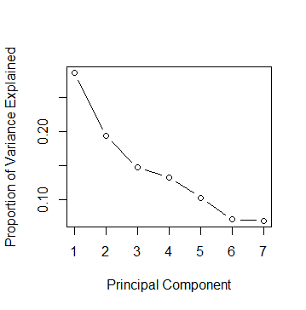

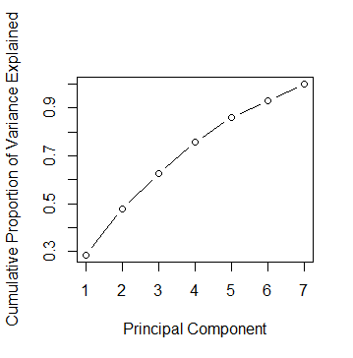

The cumulative proportion chart shows that First 6 variables explain almost 94% of total variance.

Therefore, we can remove “CHRONILL” without compromising on the explained variance

**Question 2**

Using the family lung functiondata described in AppendixA deﬁne a new variable RATIO = FEV1/FVC for the fathers. What is the correlation between RATIO and FEV1? Between RATIO and FVC? Perform a principal componentsanalysisonFEV1andFVC,plottingtheresults.PerformaprincipalcomponentsanalysisonFEV1,FVC,andRATIO.Discusstheresults

**Solution:**

Correlation between “RATIO” and “FFEV1” = 0.1832515 or 18.32%

Correlation between “RATIO” and “FFVC” = 0.2192122 or 21.92%

**PCA on FEV1 and FFVC**

Importance of components:

PC1 PC2

Standard deviation 1.3843 0.28943

Proportion of Variance 0.9581 0.04189

Cumulative Proportion 0.9581 1.00000

The proportion of variance after applying PCA is given below:

FFEV1, FVC

0.95811472, 0.04188528

This show that FFEV1 explains 95.81% of total variance.

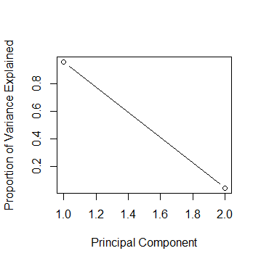

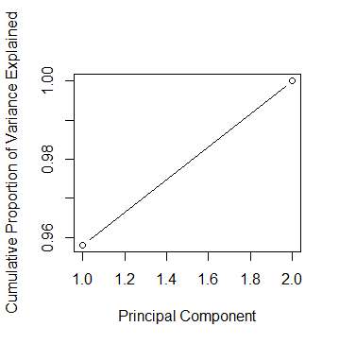

Since FFEV1 explains 95% of variance, we can remove FVC without compromising on explained variance.

**PCA on FEV1, FFVC and RATIO**

The proportion of variance after applying PCA is given below:

Importance of components:

PC1 PC2 PC3

Standard deviation 1.385 1.0395 0.05047

Proportion of Variance 0.639 0.3602 0.00085

Cumulative Proportion 0.639 0.9991 1.00000

'FFEV1', 'FFVC', 'RATIO'

0.6389900905, 0.3601606781, 0.0008492313

This shows that FFEV1 and FFVC explains 99.9% of total variance

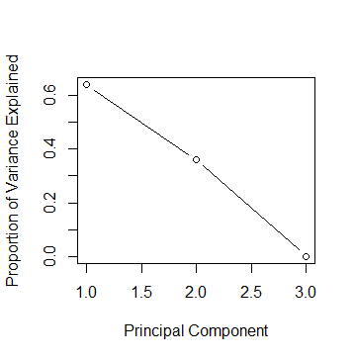

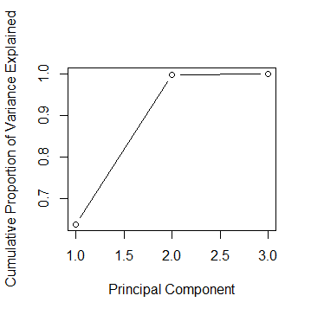

**The cumulative proportion graphs show the importance of FFEV1 and FVC which constitute 99.9% variance. Therefore, we can remove RATIO without compromising on explained variance.**

**QUESTION 3**

**Using the family lung function data, perform a principal components analysis on age, height, and weight for the oldest child.**

**Solution:**

**PCA on ‘OCAGE', 'OCHEIGHT', 'OCWEIGHT’**

The proportion of variance after applying PCA is given below:

Importance of components:

PC1 PC2 PC3

Standard deviation 1.665 0.39538 0.26799

Proportion of Variance 0.924 0.05211 0.02394

Cumulative Proportion 0.924 0.97606 1.00000

‘OCAGE', 'OCHEIGHT', 'OCWEIGHT’

0.92395261 0.05210831 0.02393908

This shows that OCAGE explains 92.3% of total variance

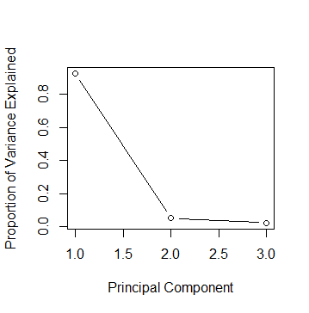

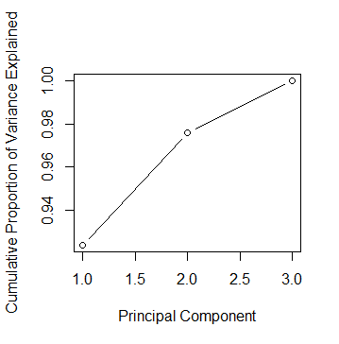

**The cumulative proportion of variance shows that ‘OCAGE’ explains 92% of total variance. Therefore, we can remove OCHEIGHT and OCWEIGHT without compromising on explained variance.**